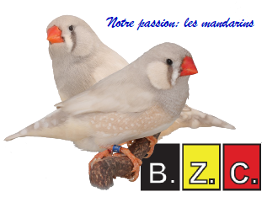
Questionary
1. What is the origine of your bird- and breeding hobby? And your preference for zebra finches
2. What colours do you breed … (mutations or combinations). Why that colour? What are the caracteristics your looking after?
3. Define the ‘English’ type, form and plumage
4. Is colour in England of great importance? What are judges expecting of the colour in England?
5. Describe your breeding space. Do you have a seperate space for the youngsters?
6. Describe your daily ‘zebra finch-work’ ?
7. How do you select birds for a show and how do you prepare them?
Do you show always couples? What about showing individuals?
8. Tell us about the food? Seed, vitamins, eggfood and other?
9. Describe your cage for breeding: material, dimensions, …
10. Selecting a couple: ho wand why?
11. Breeding problems: reasons and solutions. Give an example
12. Are you member of a club? Advantages?
13. Your breeding season: winter or summer? Why?
14. What about couples dthat doesn’t breed, doesn’t look after the youngsters? How do you treat them?
15. Some advice for a starting breeder?
16. What is the most difficult: size? Type? Plumage? Colour? Why? How do you improve your birds?
17. Is their a future for bird breeding and for specialised clubs for zebra finches?
18. Keeping your breeding space and cages clean? How? Periodicy? Products ussed? …
Please join photos of your space, your birds, youngsters
Do not forget a photo of yourself for the introduction
Please ad dan introduction: where in England do you live, club you belong to, your occupation, other hobbys, ..
you do not need to answer all the questions and you may add some data of your own
Thanks
Belgische Zebravinken Club
vzw sinds 1988 numéro
KBOnr: 0438.384.669
Sociale zzetel: De Volderstraat 1
9800 Deinze
Vlaanderen
RPR Gent
www.bzc-zebravinken.be

